**Requirements & Specification Document**

**Preface:**

This document is intended to explain the requirements for the In Class Quizzing App, Server, and Database.

**Introduction:**

This project consists of a quiz app that can be utilized by professors to effectively quiz their students in class either on the fly or pre-planned. The app will Android based. The quizzing process will consist of the professor logging into their web based professor portal where they have the option to create a quiz using either True/False, Multiple Choice, or Short Answer questions. The professor will have the option to either set a time and date for the quiz to be implemented or they could write a quick quiz right in the classroom and send it to the students immediately. The students will have the app downloaded on their phones and will log in with their username and password which will be created on first use of the app. They will then select the class that they are currently attending which could be password protected based on the preference of the professor. Once in the class page, the students will be able to click on the quiz and take it, immediately submitting their answers once finished. The quizzes also have the option of being timed. This project requires at least 3 components: A web portal for the professor, a database that stores quizzes, student and professor information, and student answers, and an app for the students to take the quiz and check their grades.

**User Requirements:**

**Web Portal:**

1. Login page that securely connects to the database.
2. Home page that displays options to go to previous quizzes or create new quiz.
3. Page to create a new quiz. - (deploy now or later, if deploy set time limit, or automatically deploy at a preset time)
4. Page to check existing/previous quizzes.
5. Professor should be able to manually change grades if needed.
6. Must include a forgot password button.
7. Must securely connect to database where user information is stored.
8. Must include a simple menu with buttons to create a new quiz or look up a previous quiz.
9. Include a text field to ask how many questions there will be on the quiz.
10. Include a text field to ask how many choices there will be per answer.
11. Dynamically generate the text fields needed for question input.
12. Dynamically generate the multiple choice text fields needed for solution input.
13. Generate a list of previous quizzes that are selectable.
14. When the user selects a quiz the page displays the questions along with the number of students who chose each answer.

**Server/Database:**

1. Secure connection.
2. Connection will be stable.
3. Submitted answers will be stored correctly.
4. Server/Database runs smoothly without delay.

**Android Application:**

1. Log in page connects to database.
2. Click on list of classes.
3. Click on a list of quizzes available.
4. A page displays the question with either multiple choice answers or a dialog box for extended response/short answer.
5. Submit quiz, which returns back to the available quizzes screen.
6. Student is able to review their grade on the quizzes screen.

**Admin:**

1. Able to add and delete professors as needed.
2. Able to add and remove students.
3. Make changes/update system if needed.
4. Reset passwords.

**System Architecture:**

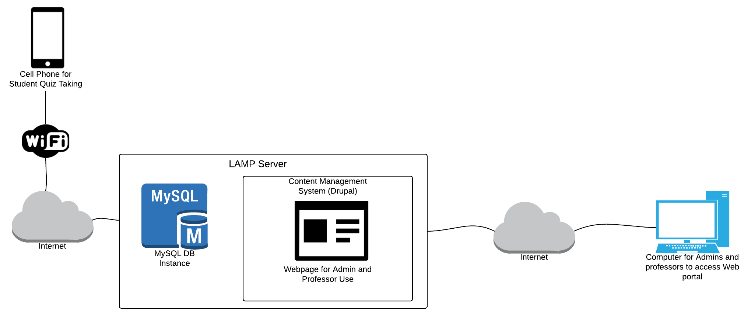

**Quiz Process Diagram:**

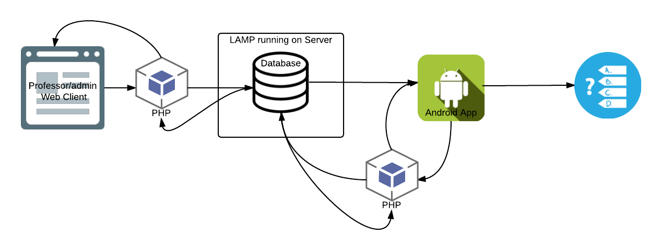

**System Requirements:**

**Web Portal:**

1. The content management system that we will be using is Drupal. To set up all of the pages on the website we will be using various modules to create the forms and other tools needed.

**Server:**

1. The server will consist of a LAMP instance running on a private server.
2. The server will have the capability of talking securely with both a web portal and the Android application.
3. The server will contain a database that holds all the information for the users of the app and the portal.
4. The server has enough space to host the database and hold as much information as necessary.
5. The server has some form of security running on it, to provide the best security for the users.

**Database:**

1. The database will use MySql and php and will run within the lamp instance.
2. The database will have the proper amount of storage space to ensure it runs smoothly.
3. The database will have effective indexing methods to make sure the data is delivered to the correct location.
4. The database will hold tables for: Student Information, Professor Information, Class Information, Quiz Questions, Quiz Answers, Student Grades, and Past Quizzes